

Project: Wedding Invitation and Gift Management System (WIGMS)

Second Progressive Report

V1.1

GROUP 3
NAME | MATRICULE | PERCENTAGE PARTICIPATION
TCHOUNGA NGATCHOU MARIE CLAIRE | 26S022 | 25%
MASSADO DJOKO AICHA CLAUDIA | 26S033 | 25%
NKOMPNANG GUILLAUME JUNIOR | 26S017 | 25%
AVOUTIA DONGMO BRAYANN | 26S028 | 25%

SUPERVISOR: MR MBIETIEU AMOS
Academic Year: 2025/2026

Table of Contents

- Introduction ……………………………………………………………………….3

- Gantt Chart ………………………………………………………..3

- System Design …………………………………………………………………3

- Sequence diagram……………………………………………………………4

- Deployment diagram………………………………………………………….4

- Class diagram…………………………………………………………………6

- Work distribution………………………………………………………………6

- User Interface………………………………………………………………….6

- Module One…………………………………………………………………….7

- GitHub Repository……………………………………………………………10

- Module Two…………………………………………………………………..13

- Repository Link……………………………………………………………….14

- Graphic User Interface………………………………………………………15

- Tools And Technologies used……………………………………………..15

- Difficulties encountered and Proposed Solutions………………………...16

- Next steps of the project……………………………………………………..17

- Conclusion…………………………………………………………………….17

Introduction
The aim of this project is to design and implement a Wedding Invitation and Gift Management System using the C programming language. The system is developed using a modular approach, allowing each component to be built, tested, and improved independently.
This second report presents:
• The corrected version of Module 1: Person Management based on supervisor remarks
• The implementation of Module 2: Category Management
Special attention was given to improving the user interface, ensuring better usability before proceeding with advanced modules.

Gantt Chart

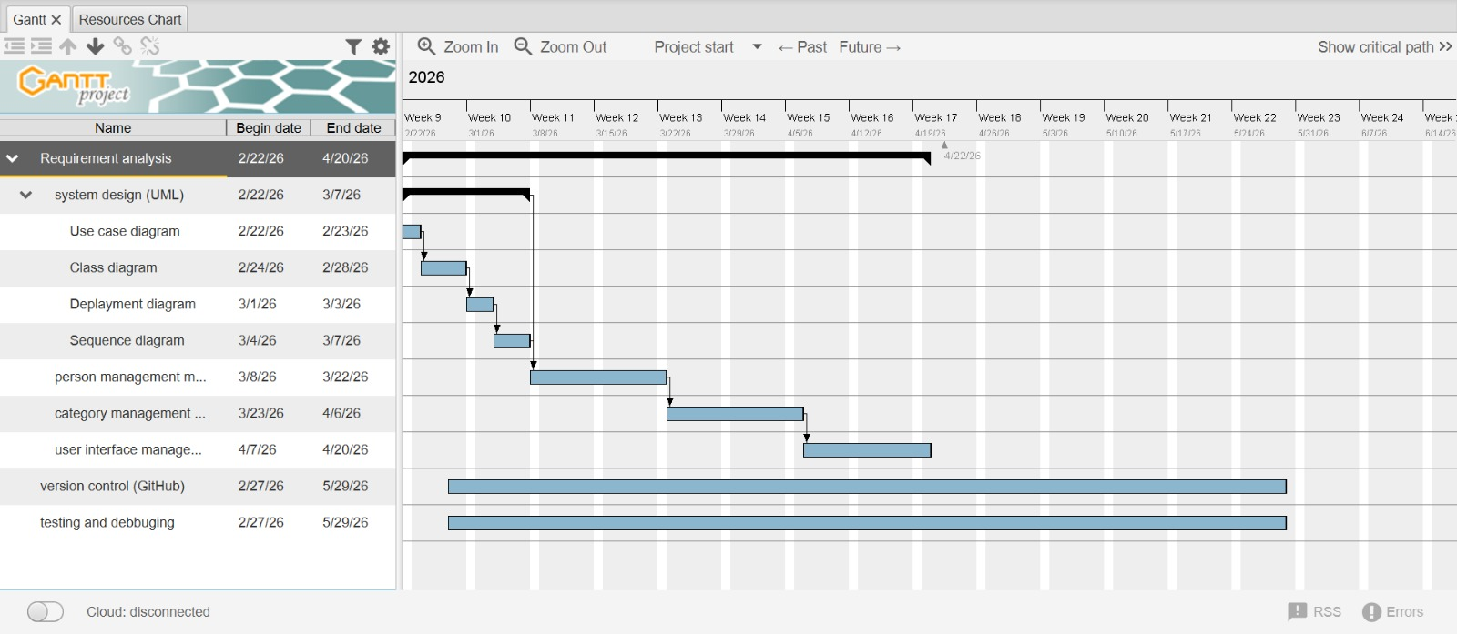

System Design
  - Use Case Diagram
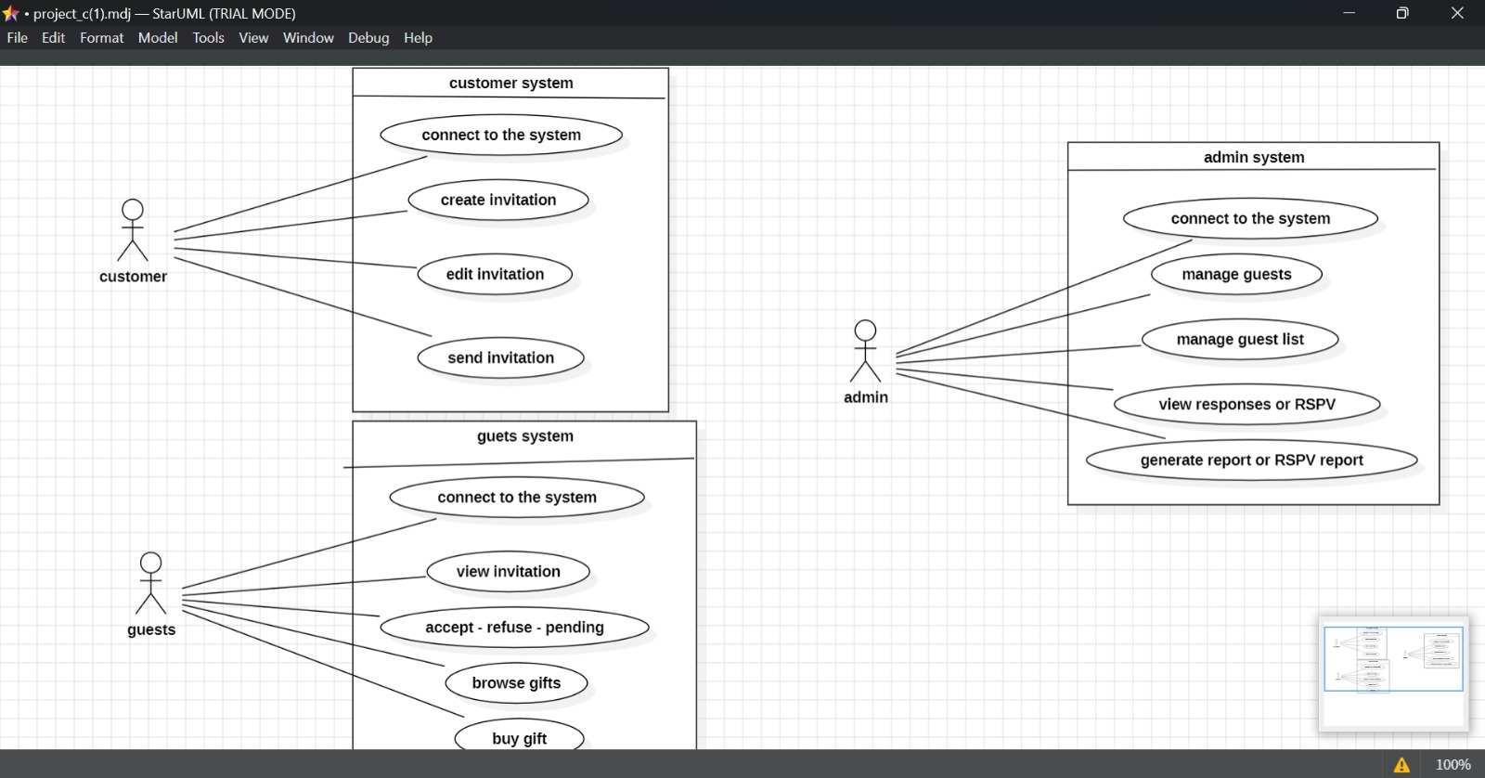

3.2 Sequence Diagram
3.2.1 Guest list management sequence
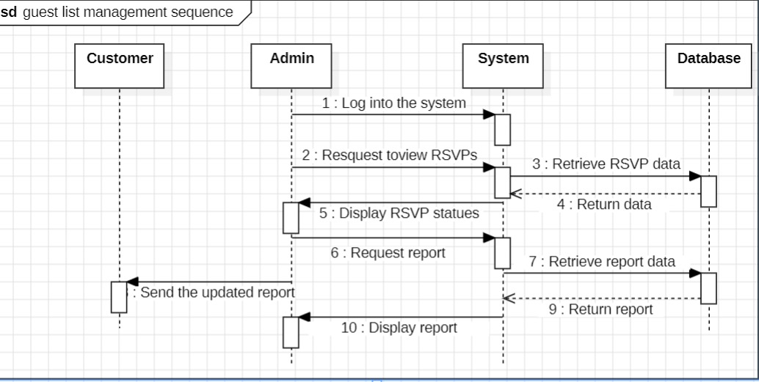

3.2.2 Invitation creation sequence
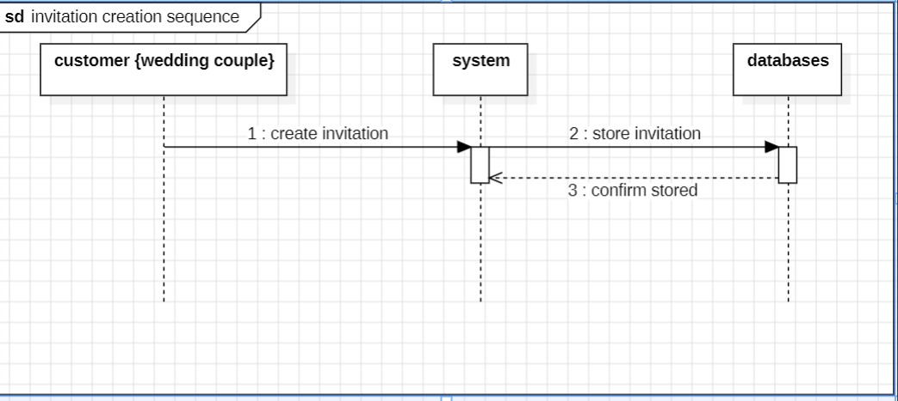

    - Respond sequence
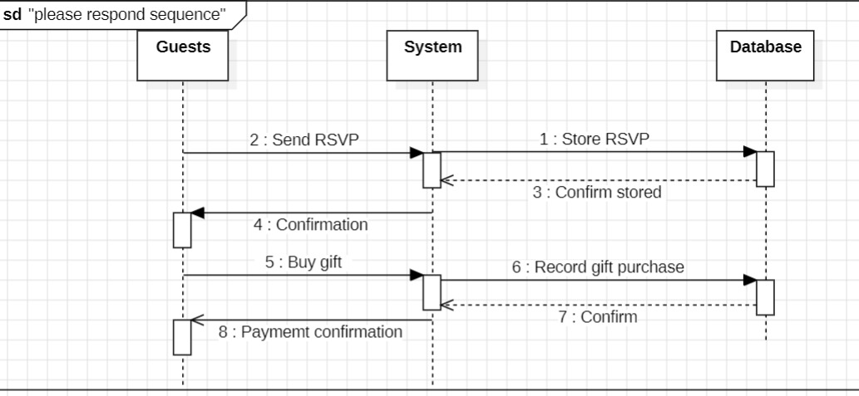

Deployment Diagram
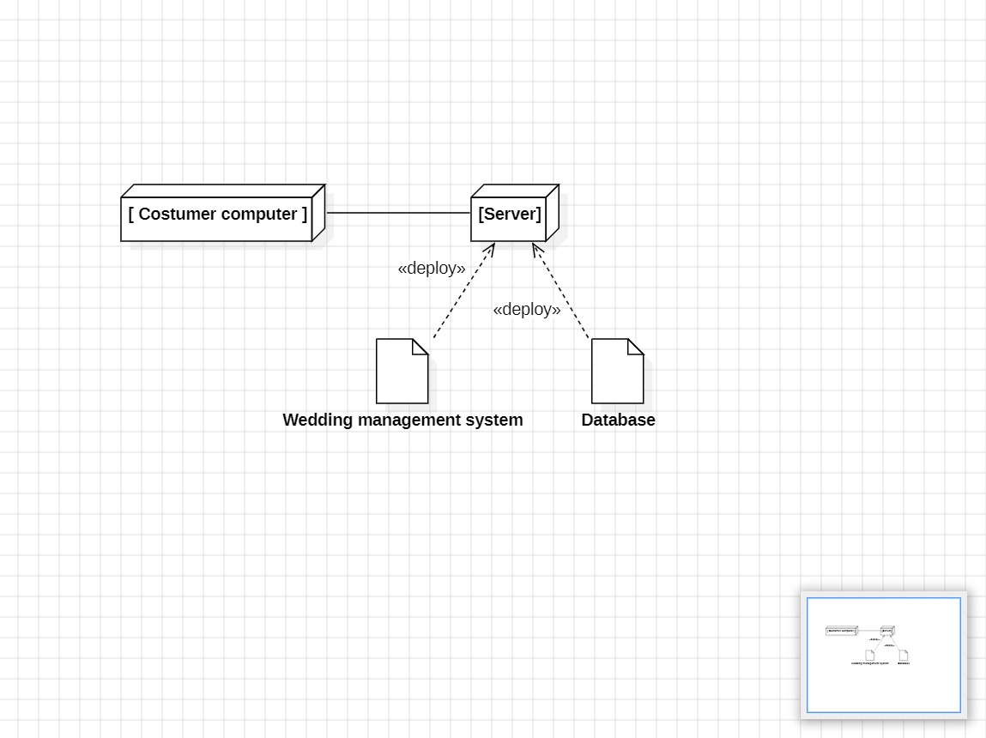

Class Diagram

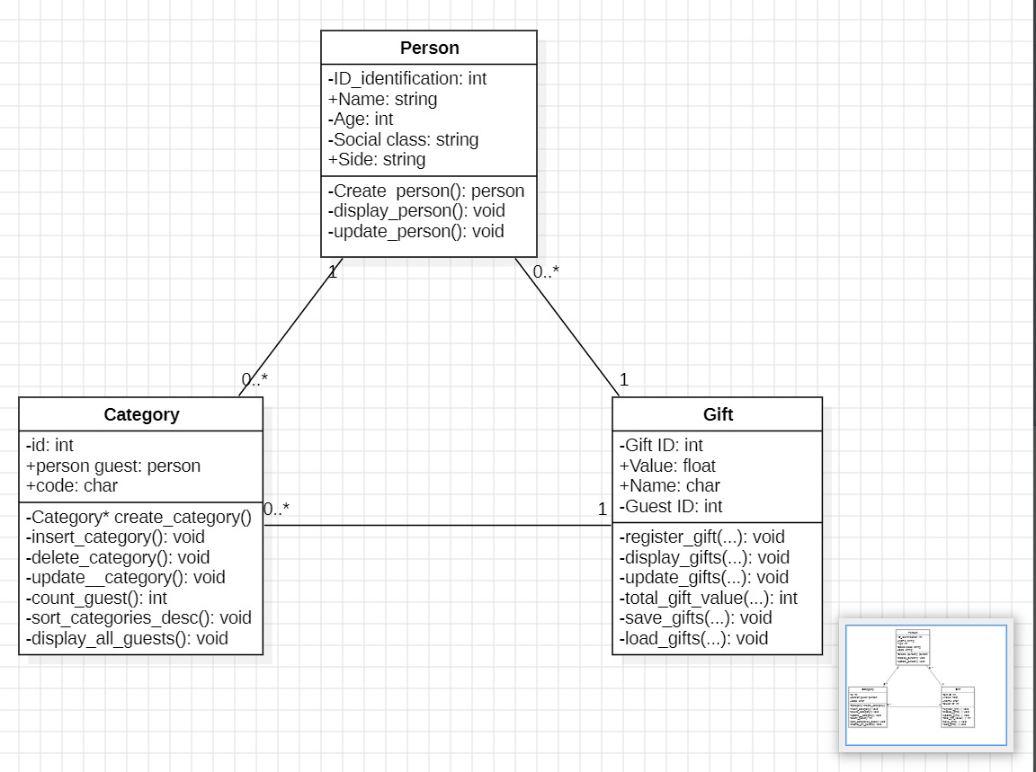

Work Distribution

Group Member | Role | Assigned Tasks
Tchounga Ngatchou Marie Claire | Module Design | Designed Category structure& User Interface
Avoutia Dongmo Brayann | Function Implementation | Implemented add_category()
Nkompnang Guillaume Junior | Display Function | Implemented display_categories()
Massado Djocko Aicha | Update Function | Implemented update_categories()

User Interface
To improve interaction with the system, a simple user interface was introduced using standard input/output functions in C. The interface allows users to navigate through the program using a menu-driven approach.
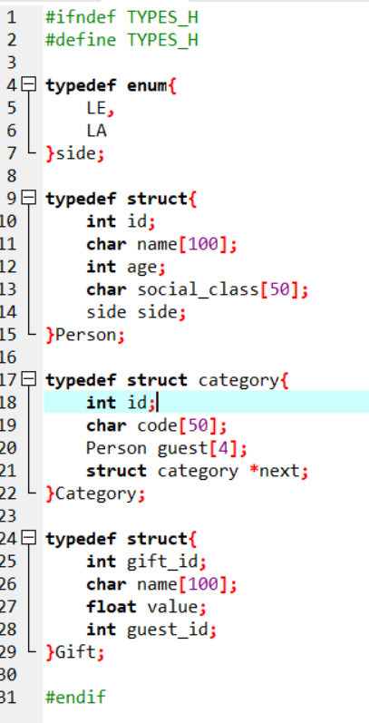

MODULE 1 : PERSON MANAGEMENT

Objectives of the Module
- Define a Person structure to store guest information.
- Implement a function to create a new person.
- Implement a function to display a person's information.
- Implement a function to update a person's information.
- Apply structured programming concepts using C language.

- Person Structure
A Person represents an invited guest. The structure stores basic information such as ID, name, age,
social_class.
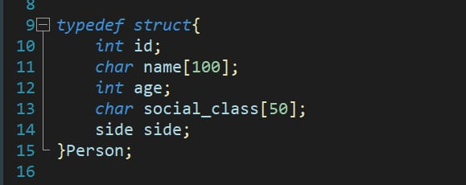

Implemented Functions

create_person ()

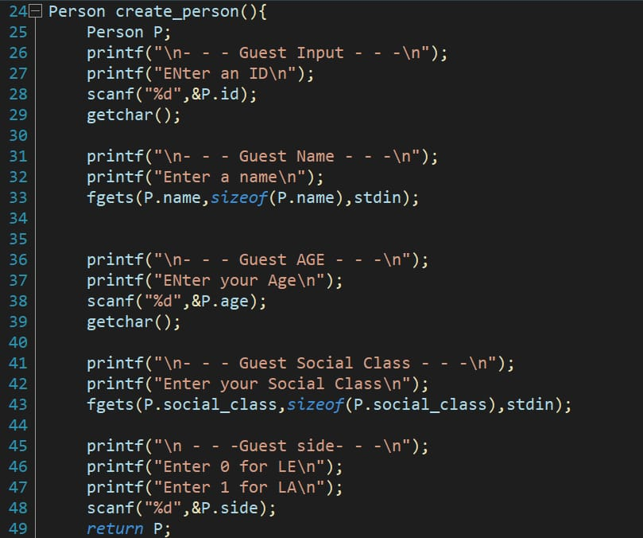

display_person ()

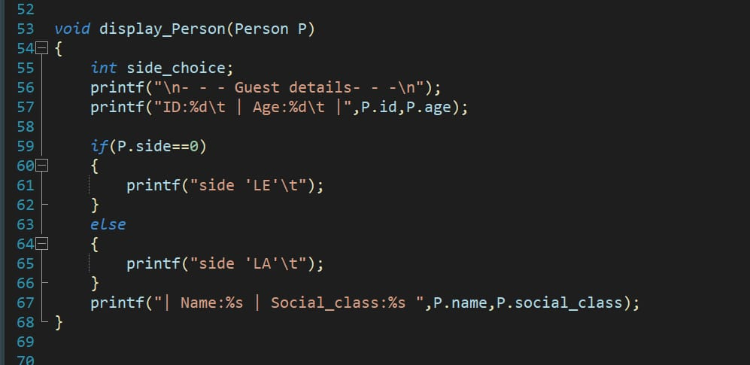

Graphic User Interface

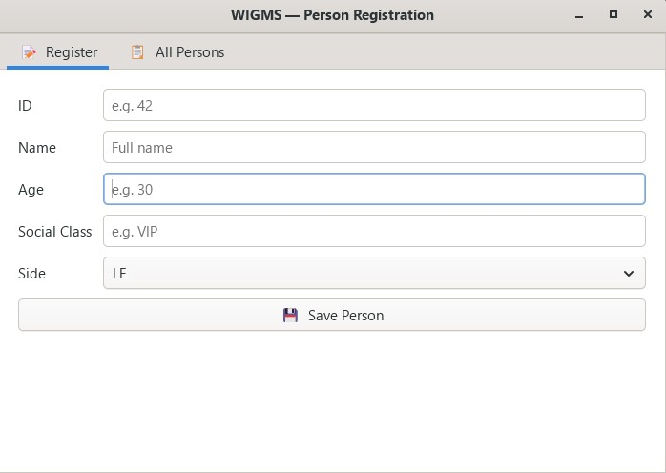

Setting Up a GitHub Repository
To create a GitHub repository using the web interface, follow these steps:

Step 1: Creating the GitHub accounts
To sign up for an account, navigate to https://github.com/ and follow the prompts. To keep your GitHub account secure you should use a strong and unique password.

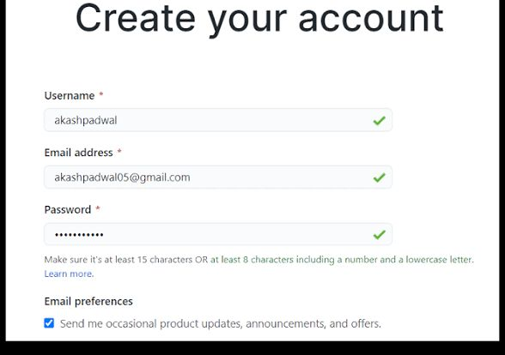

Step 2: Creating the Repository
Start a new repository in the upper-right corner of any page, select the plus (+) icon, then click New repository

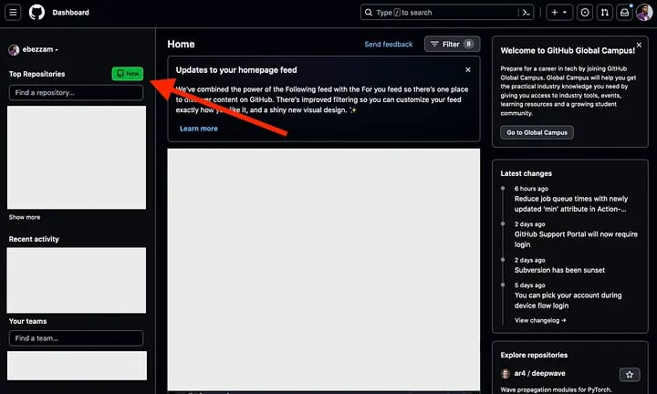

Step 3: Specify an owner
If you belong to any organizations, use the "Owner" dropdown menu to select the account (your personal account or an organization) that will own the repository. Enter a name — type a short, memorable name for your repository in the "Repository name" box.

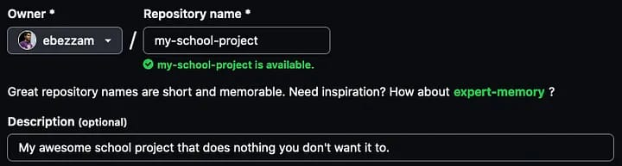

Step 4: Choose repository visibility
Decide whether the repository will be Public (anyone can see it) or Private (only you and collaborators you choose can access it).

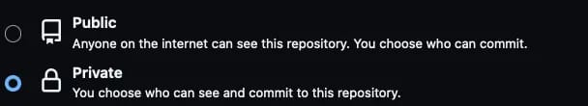

Step 5: Initialize the repository
Select Add a README file to create a document that describes your project. You can also optionally add a .gitignore file (to exclude specific file types from version control) and a license.

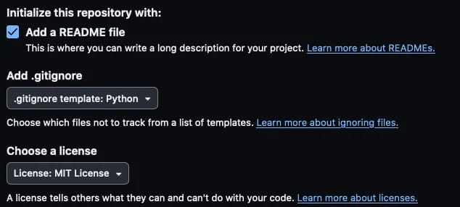

Step 6: Create the repository
Click the green Create repository button at the bottom of the page.

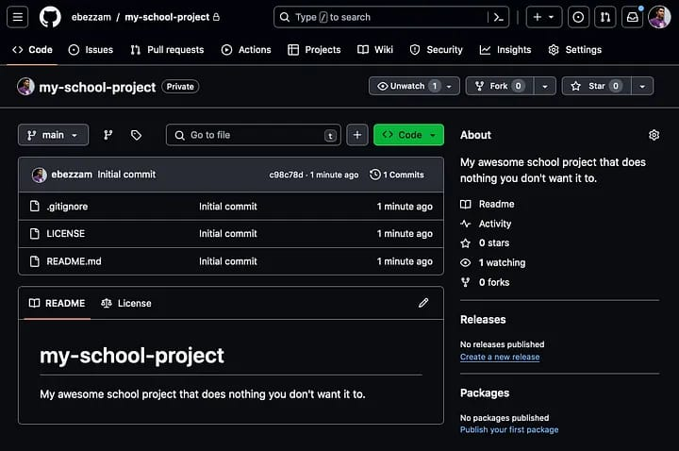

Step 7: Start using your repository
GitHub repository is now created and ready for you to start adding files and managing your project with version control. You can then clone the repository to your local machine using the provided URL to work with it locally.
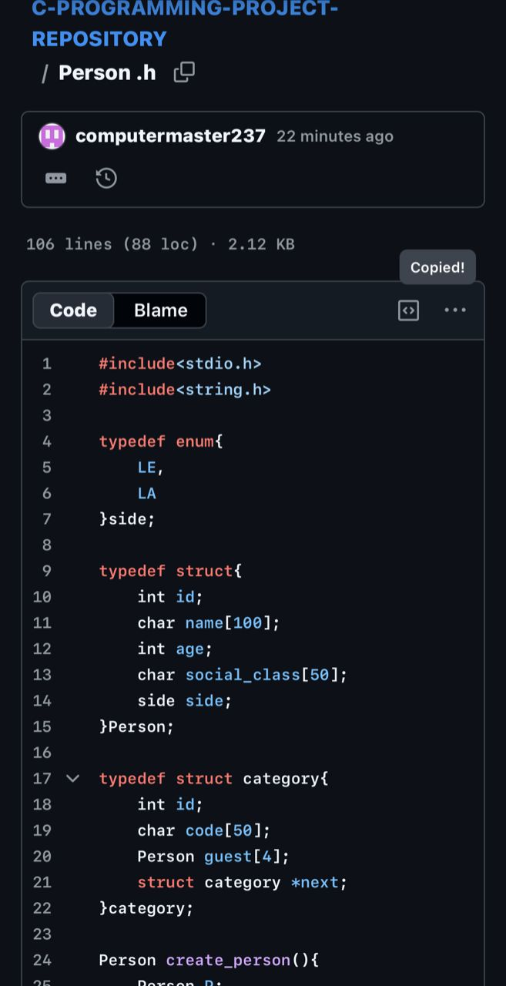

MODULE 2: CATEGORY MANAGEMENT

Objectives

• Organize guests into categories
• Use linked lists for dynamic storage
• Improve system structure

Category Structure

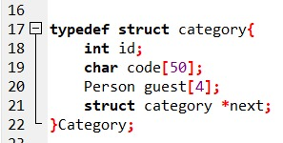

Implemented Functions
3.1 Create_Category

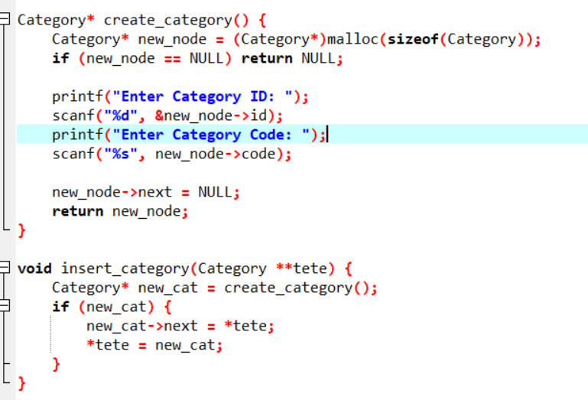

3.2 Update_category
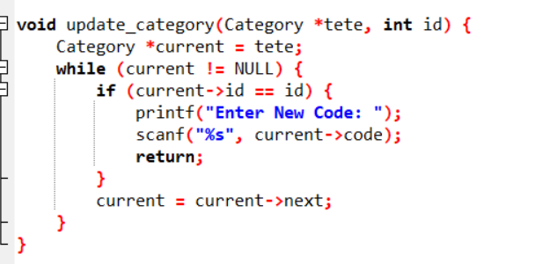

3.3 Delete_category

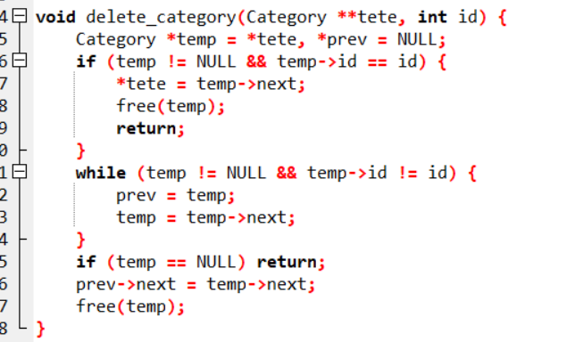

Linked List Explanation
Categories are stored using a linked list:
• Each node represents a category
• Nodes are connected using pointers
• Allows dynamic insertion and deletion

Repository

The GitHub repository was created and validated by all group members. The project can be accessed using the following link: https://github.com/C-programming-project-1/C-PROGRAMMING-PROJECT-REPOSITORY

Graphic User Interface (GUI’s)

6.1 Location of the file
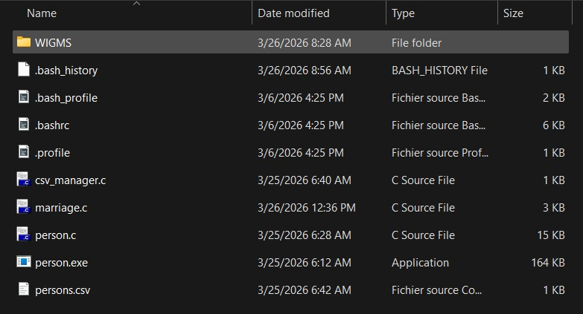

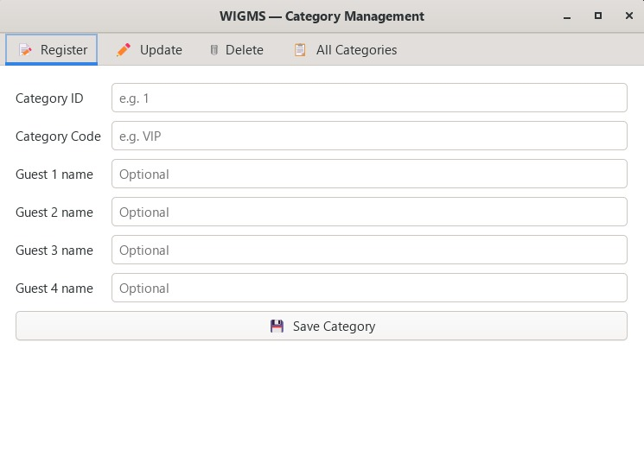
6.2 Presentation of the Category user interface

Tools and Technologies Used

- C Programming Language for software development.

- GitHub platform for version control and team collaboration.


- Standard C libraries such as stdio.h and string.h

Difficulties Encountered and Proposed Solutions
During the development of the Wedding Invitation and Gift Management System, the group encountered several general challenges that affected both Module 1 and Module 2. These challenges were related to programming concepts, system design, and teamwork. However, appropriate solutions were applied to ensure the successful progress of the project.
8.1 Difficulty in Managing Dynamic Data Structures
The implementation of linked lists in Module 2 introduced another challenge. Unlike static data structures such as arrays, linked lists require proper handling of memory allocation and pointer connections between nodes.Errors such as incorrect linking of nodes, loss of data, and program crashes occurred during testing.
Proposed Solution:
The group used diagrams to visualize how linked lists work and how nodes are connected. Step-by-step tracing of the code was performed to identify errors. Additional practice on linked lists helped improve understanding and correct implementation.
8.2 Difficulty in Handling User Input
Managing user input using functions like scanf () was problematic, especially when handling both strings and integers. Issues such as skipped inputs and incorrect data reading were encountered.
Proposed Solution:
The group reviewed proper input handling techniques and improved the structure of input statements. Additional validation checks were introduced to ensure correct data entry. Extensive testing was conducted to eliminate input errors.
8.3 Difficulty in Time Management and Task Coordination
Coordinating tasks among group members and meeting deadlines was sometimes difficult due to different schedules and workloads.
Proposed Solution:
Tasks were clearly assigned to each member, and deadlines were set for each phase of the project. Regular communication and progress tracking ensured that the work was completed on time.

Next Steps of the Project
The next phase will focus on:
• Implementing Priority Management (sorting algorithms)
• Developing Gift Management module
• Designing the User Interface
• Testing and debugging of system.

Conclusion
This second report highlights both the correction of Module 1 and the successful implementation of Module 2.
The project has significantly improved the group’s understanding of:
• Structures
• Pointers
• Linked lists
• Modular programming
Additionally, the introduction of a user-friendly interface has made the system more interactive and efficient.
This module lays a strong foundation for the continuation of the project.
PKFokam Institute of Excellence — C Programming Course — Academic Year 2025/2026

